**Adruino Micro Controller Project – Proposal**

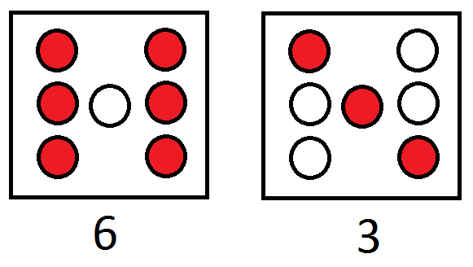 Our team project will be a simple dice diode combination. Essentially we want to hook up light emitting diodes on the bread board along with some resistors to control voltage and current flow. We would like to make a program that randomly generates a diode combination that is represented by the number on a dice. For example on the right you can see the different combinations. This will be controlled by a button press. We will be testing the nine volt battery connector, the Adruino kit battery pack, or the wall charger. The program should be simple once we get the diodes connected in the final arrangement. The build should use seven light emitting diodes along with seven resistors. Guessing from the diodes given in the lab kits and the 9V battery pack we are roughly guessing the resistors should be between 150 and 300 ohms. The main issues we are going to have with this project will be the possibly complicated wiring but mostly the program which will be both presumably long and complex.

