Project Proposal – EE 292

Robert Johnson

Dale Mace

Cody Helbert

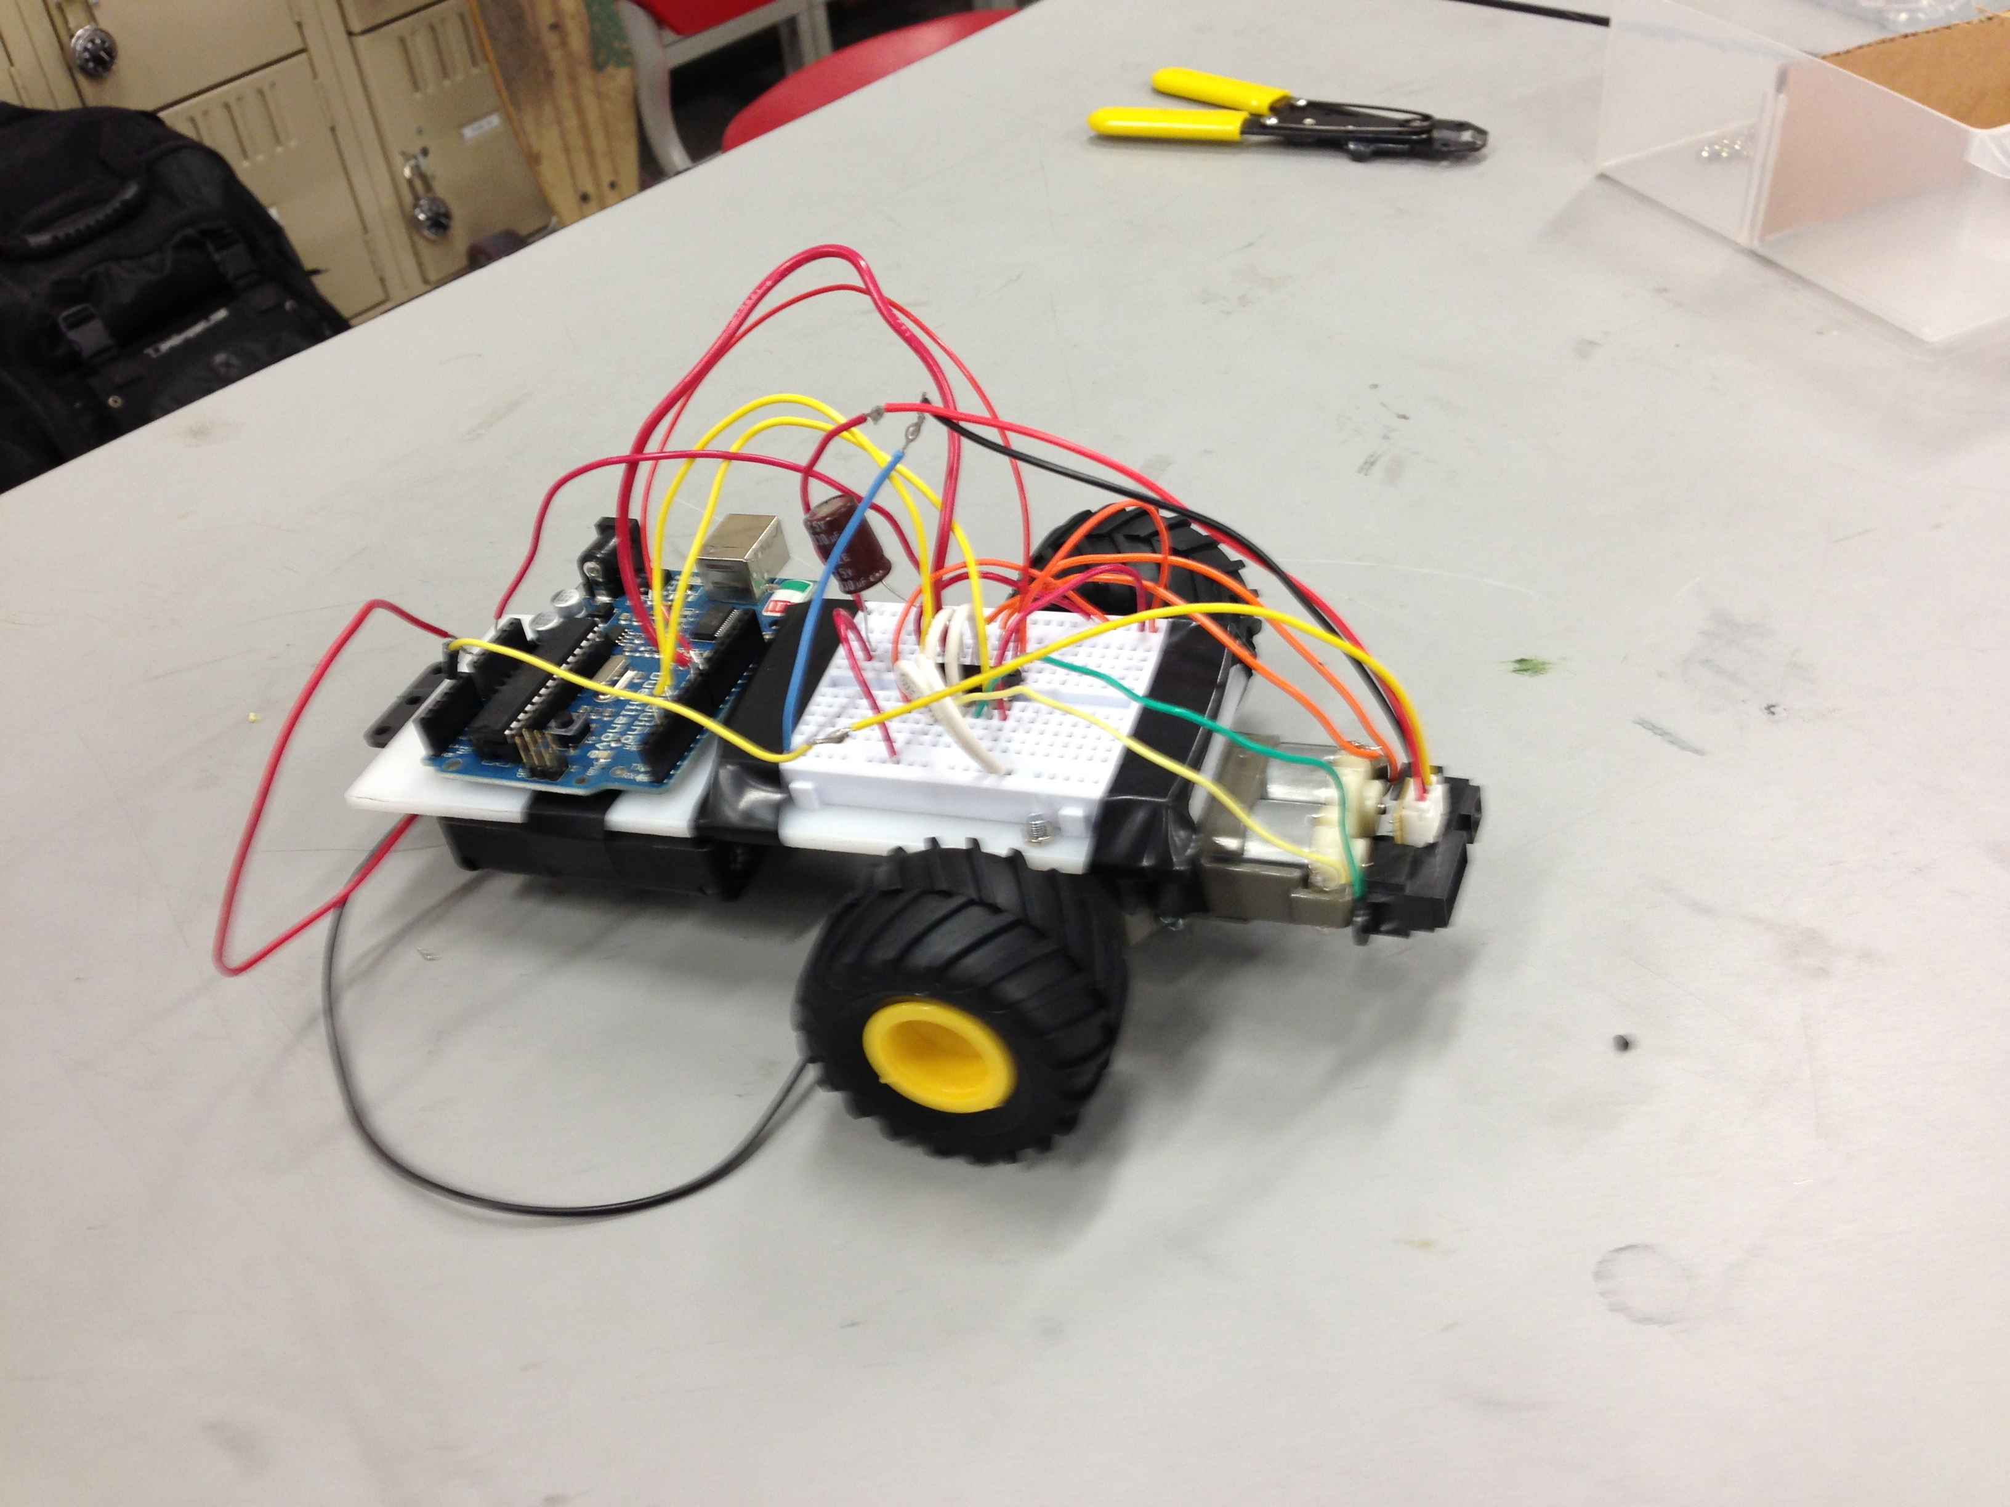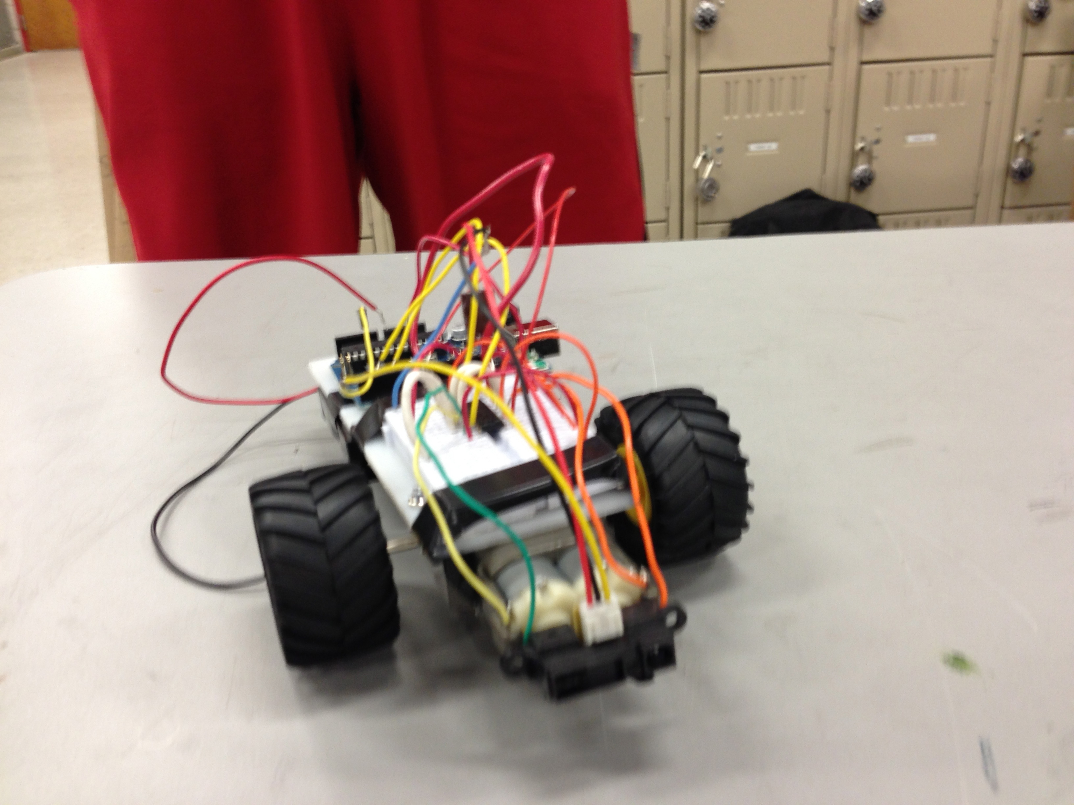

For our final project we will be using the Arduino Kit to create a mechanism for buzzing in on a quiz show. We will be using three switch buttons for contestants to depress when they know the answer. Each contestant will have a corresponding LED. Only the LED corresponding to the contestant who answer’s first will light up and stay light for five seconds, giving the contestant enough time to answer. The main components will be the Arduino kit, which we will program, a 9V battery to power the LED lights, and the three switch buttons. The switch button that came with our kit may be too small to actually be functional. Therefore, we are still looking for a more functional buzzer/switch button.