EE 292 Project Proposal

Group Members:

Arvi Balbin

Faezeh Basardeh

Robert Deike

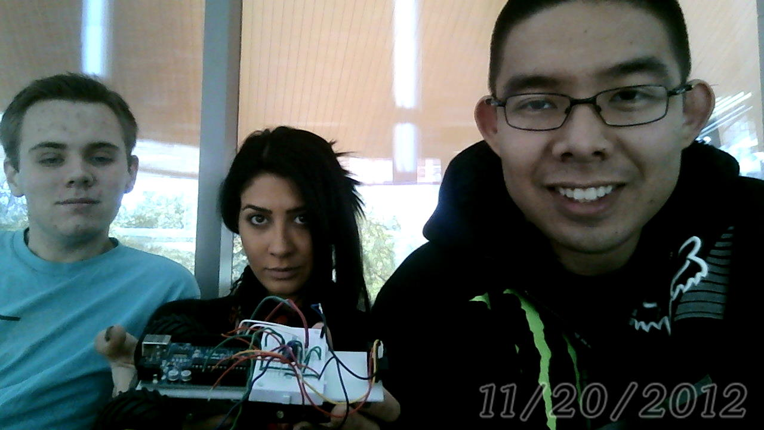

From left to right: Robert, Faezeh, Arvi

Final Project Description:

The final project for our group would be a motion sensor alarm. The project would be using the Arduino micro controller, bread board, a speaker, and an IR sensor. The IR sensor would detect any type of motion that would pass through it. Once the sensor is tripped, the Arduino would then use the speaker to create a sound for a certain amount of time. A LED might also as an indicator that the alarm is on when the sensor is tripped.