Ajericho Malia

Carl Ajuziem

Ruchir Kaul

EE 292

Project Proposal

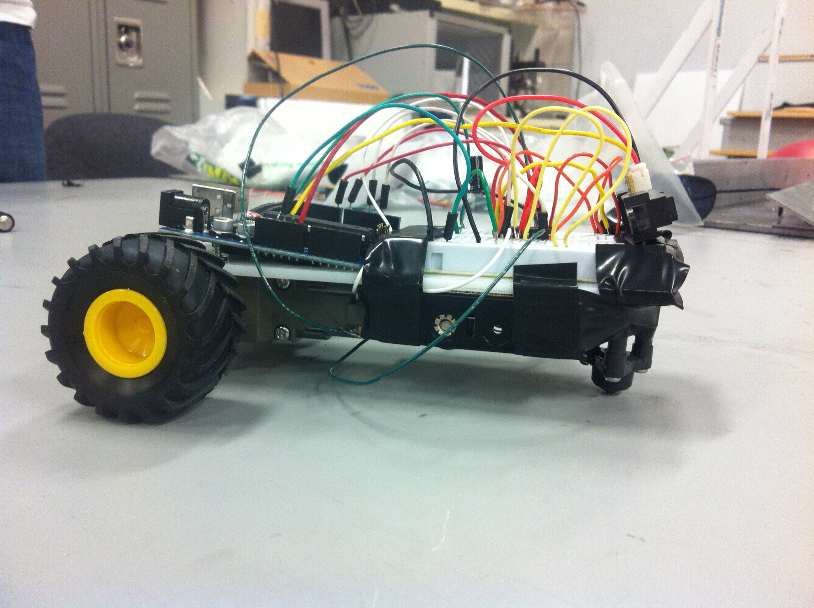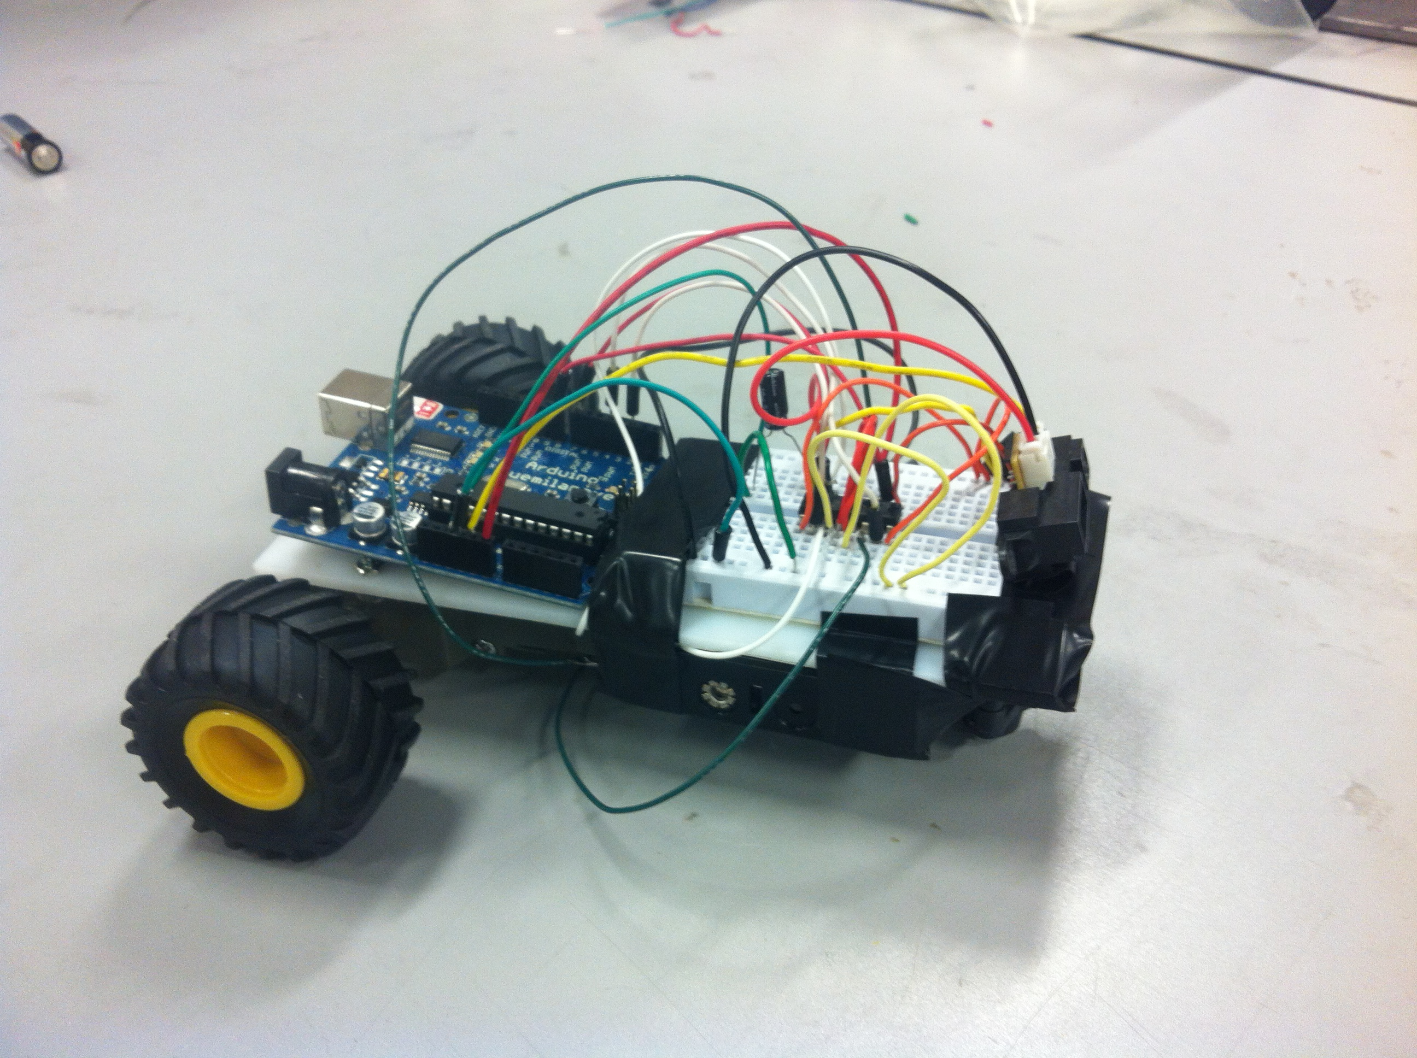 For our project, we will be making a tailgate sensor using the Arduino kit. In a bustling city like Las Vegas, there are crazy drivers that ride up on you from bumper to bumper, so an invention like a tailgate sensor would have a very practical use in today’s world. The main components we will be using are the Arduino, the breadboard, a battery, a motion sensor, and an LED. How this project will work is the tailgate sensor will be attached to an object. We will program the sensor at a set distance that is relative enough to be considered as “tail-gating” in a real life scenario. As projected, once a different object gets too close to the sensor of the first object, the LED will light up indicating that the object is too close and is tailgating.